NAME: _____________________________________ CLASS______ DATE: __________

SCHOOL _________________________________________________________________

**CHEMISTRY**

**FORM 4**

**PAPER 2**

**END TERM 1 EXAMS**

**INSTRUCTIONS TO THE STUDENTS:-**

* Write your **Name** and **Admission number** in the spaces provided.
* Answer ***all*** the questions in the spaces provided.
* All working **MUST** be clearly shown where necessary.

**1**.The following is an extract of the periodic table. Study it and answer the questions that follow. The letters do not represent the actual symbols of the elements.

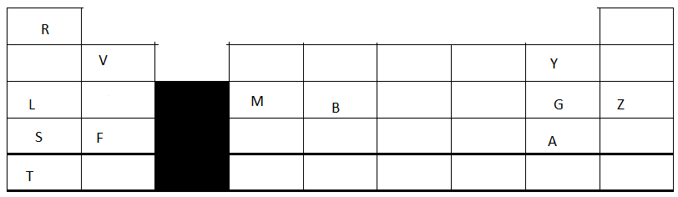

a) State the name given to the groups the following elements belong; (1mk)

i) Z

ii) Y, G and A

b) **Compare** the following;

i) The atomic and ionic radius of element V. (1 ½ mk)

ii) The melting points of elements G and Z (1 ½ mk)

c) The oxide of M reacts with both dilute acids an alkalis. Write a balanced chemical equation to show how the oxide reacts with dilute sodium hydroxide solution. (1mk)

d) Choose the letter that represents the element that is ; (1mk)

i) the most reactive metal ---

ii) the strongest oxidizing agent----

e) Elements L and M are good conductors of electricity but M is a better conductor than L. Explain. (1mk)

f) Explain how sodium hydrogen carbonate solid can be used to differentiate between solutions of the chlorides of L and B. (2mk)

g) 4.1 grams of the nitrate of F was strongly heated until a constant mass was obtained.

i) Write a balanced chemical equation for the reaction that took place. (1mk)

ii) List any observation made during the heating (1mk)

iii) Calculate the total volume of the gaseous products obtained if the reaction took place at room temperature and pressure. (1mole of gas at RTP=24dm3, N=14, O=16, F= 40). (2mk)

**2**. The table below shows the solubilities of potassium nitrate at different temperatures.

|  |  |  |  |  |  |  |  |  |  |  |
| --- | --- | --- | --- | --- | --- | --- | --- | --- | --- | --- |
| Temperature 0 c | 10 | 20 | 30 | 40 | 50 | 60 | 70 | 80 | 90 | 100 |
| Solubility g/100g of water | 80 | 88 | 96 | 104 | 114 | 124 | 136 | 148 | 162 | 180 |

a) Plot a graph of solubilities of potassium nitrate against temperature. (3mk)



b) From your graph determine;

i) the solubility of the potassium nitrate at 650c. (1mk)

ii) the mass of potassium nitrate that would **dissolve in 50g of water at 820c**. (2mk)

c) Determine the molar concentration of potassium nitrate at 370 c. (N=14, O= 16, K= 39. Assume the density of solution to be 1g/cm3 ) (3mk)

d) 130g of potassium nitrate salt was added to 100g of water and heated to 900c. It was then cooled to 150 c.

i) At what temperature were the crystals first formed? (1mk)

ii) Calculate the mass of crystals formed. (1mk)

e) C17H35COONa is cleansing agent used to remove dirt from clothes. It is manufactured by hydrolyzing vegetable oil using 4M NaOH hydroxide solution. After boiling for sometime, adding small amounts of distilled water and stirring, a certain compound is added.

i) Name the compound added and state its role. (2mk)

ii) Describe the mode of action of the cleansing agent. (3mk)

**3**. a)Chlorine gas is prepared in the laboratory by reacting concentrated hydrochloric acid with an oxidizing agent like potassium manganate (VII)

i) List other two oxidizing agents that can be used in place of KMnO4 (1mk)

ii) Freshly cut blue flower petals were placed in a gas jar containing oxygen and another containing chlorine gas. Explain the differences in the observations made. (2mks)

iii) State any two uses of hydrochloric acid (1mk)

b) Hydrogen chloride gas was passed over heated iron powder as shown in the diagram below .Study it and answer the questions that follow.

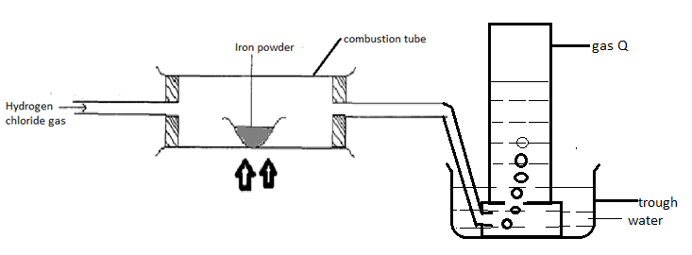

i**) State** and **explain** the observations made in the combustion tube. (2mk)

ii) Blue litmus paper was placed in the trough with water and it turned red, explain this observation. (1mk)

iii) Describe the chemical test for gas Q (1mk)

4. a) i) State any two adaptations of the burette to perform its functions. (2mk)

ii) The Bunsen burner produces two types of flames. The non-luminous flame is mostly preferred for heating. Under what condition is the other type of flame produced and what two reasons makes it not suitable for heating.

Condition- (1mk)

Reasons - (1mk)

b) An agriculture student wanted to determine the pH of a soil sample in order to know the fertilizer to add to the soil upon planting. Describe the procedure the student would have followed to determine this soil pH. (2mk)

c) The table below shows different properties of mixtures. Study it and answer the questions that follow.

|  |  |  |
| --- | --- | --- |
| Liquid | Q | J |
| Water | Immiscible | Miscible |
| Ethanol | Miscible | Miscible |

i) What physical property is used when choosing the method to separate a mixture of ethanol and J (1mk)

ii) Name two methods used to separate mixture of water and Q (1mk)

d) Use **well labelled diagrams** to show how a mixture of potassium chloride, anhydrous iron (iii) chloride and lead sulphate solids can be separated to acquire a pure and solid sample of each. (3mk)

**5.** a)i)Define the term enthalpy of formation (1mk)

ii) Use the information below to answer the questions that follow.

Equation enthalpy

H2 (g) + ½ O2(g)  H2O(g) ∆H= -286kJmol-1

C(s) + O2(g) CO2(g) ∆H= -394kJmol-1

2C(s) + 3H2 (g) + ½ O2(g) C2H5OH (l) ∆H= -277kJmol-1

I) Draw an energy cycle diagram linking the above enthalpies with the molar enthalpy of combustion of ethanol. (2mk)

II) Hence calculate the molar enthalpy of combustion of ethanol. (1mk)

b) In an experiment to determine the molar enthalpy of displacement of copper, 100cm3 of 2M copper ii sulphate solution was placed in a plastic beaker and its initial temperature recorded as T1. Excess magnesium was then added to the beaker and thoroughly stirred until no further change in temperature occurred. The highest temperature obtained was recorded as T2.

i) Other than the temperature rise, **state** and **explain** the observations that were made during the reaction. (2mk)

ii) Calculate the heat change for the reaction above given that, T1 = 21.50c and T2= 380c.

(SHC= 4.2Jg-1k-1 and the density of the solution is 1gm/cm3) (1mk )

iii) Determine the molar heat of displacement of copper by magnesium. ( 2 mk)

iv) Write the **thermochemical equation** for the reaction that took place (1mk)

6. a i) Which type of sulphur is formed under the following conditions; (2mk)

|  |  |
| --- | --- |
| Conditions | Type of sulphur |
| Below 960c |  |
| Rapidly cooling sulphur vapor |  |
| Pouring boiling sulphur in cold water |  |
| Above 960c |  |

b) i) Fill in the gaps in the table below. (3mk)

|  |  |  |  |
| --- | --- | --- | --- |
| gas | reactants | Method of  collection | Confirmatory test |
|  | Copper, concentrated  sulphuric vi acid & heat |  | Changes purple  acidified KMnO4  colourless |
| Hydrogen  Sulphide |  | Collected over  warm water |  |
|  | Sulphur iv oxide  and  Oxygen gases |  | XXXXXXXXXXXXX |

ii) Write a balanced chemical equation for the other set of reagents that can be used to prepare sulphur iv oxide gas. (1mk)

iii) State the observation made and the property of concentrated sulphuric vi acid exhibited in each of the following experiments. 2mks

|  |  |  |
| --- | --- | --- |
| Reaction of conc. H2SO4  with; | observation | Property of concentrated  H2SO4 |
| Sugar crystals |  |  |
| Copper turnings |  |  |

c) A student from Igikiro mixed day secondary school was provided with solid G. The table below shows the procedures, observations and inferences that the student made in the lab. Study the table and fill in the missing gaps.

|  |  |  |
| --- | --- | --- |
| Test | Observations | Inferences |
| a) To a spatula full of solid G in a  Boiling tube. Divide the  Resulting solution into five  portions | Dissolves to form a  Colourless solution | 1mk |
| bi) to the first portion add  NaOH solution dropwise till  In excess | 1mk | Pb2+, Zn2+, Al3+ present |
| ii) to the second portion ,add  ammonia solution dropwise  till in excess. | White precipitate , insoluble  in excess | ½ mk |
| iii) to the third portion, add  few drops of potassium  sulphate solution. | No white precipitate | ½ mk |
| ci) to the fourth portion add  few drops of acidified  lead nitrate solution. | White precipitate | ½ mk |
| ii) to the fifth portion add  few drops of barium nitrate  solution | White ppt | ½ mk |

7. Study the scheme below and answer the questions that follow.

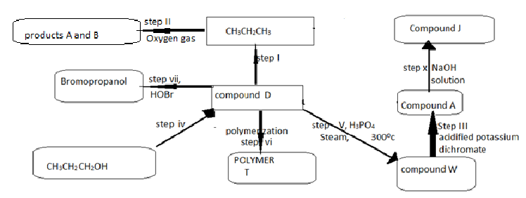

a) State the name given to the processes taking place in; ( 1 ½ mk)

Step I-

Step X-

Step V-

b) Write chemical equations for the reactions taking place in steps; (2mk)

step ii-

Step X-

c) State the observation made in; (2mk)

i) Step VII-

ii) Step III-

d) i) Draw the structure of polymer T showing 3 repeated units. (1mk)

ii) State any one use of polymer T (1mk)

e) State the reagents and conditions for the following reactions;

|  |  |  |
| --- | --- | --- |
| Step | reagent | condition |
| I | -    ½ mk | -  -  1mk |
| IV |  | -  1mk |